Experiment No: 2
Web API using ASP.NET Core with Swagger
1. Objectives
- To install and configure Swagger in an ASP.NET Core Web API project.
- To generate API documentation using Swagger UI.
- To test Web API endpoints using Swagger and Postman.
- To understand the use of Route attributes and HTTP Action Verbs.
- To implement basic Read and Write operations in a Web API.

Step 1: Create the Web API Project
Created a new ASP.NET Core Web API project using the API template in Visual Studio.
Step 2: Configure Swagger
Installed the Swashbuckle.AspNetCore NuGet package. Swagger services were registered in Program.cs using AddSwaggerGen(). Swagger middleware was enabled using UseSwagger() and UseSwaggerUI().
Step 3: Execute the Application
The application was executed successfully. The Swagger page was opened using the local Swagger URL. The API documentation displayed the available controller and its HTTP methods (GET, POST, PUT and DELETE).
Step 4: Test API using Swagger
The GET endpoint was selected in Swagger UI. Using Try it out and Execute, the response was verified successfully.
Step 5: Test API using Postman
The GET endpoint was accessed through Postman using the local API URL. The response body returned the expected data and the HTTP response status was 200 OK.
Step 6: Modify Route
The route attribute of the controller was changed from:
[Route("api/[controller]")]
to
[Route("api/Emp")]
The modified endpoint was tested again in Postman and the response was received successfully.

Important Configuration
Swagger Registration
builder.Services.AddSwaggerGen();
Swagger Middleware
app.UseSwagger();
app.UseSwaggerUI();
Modified Route
[ApiController]
[Route("api/Emp")]
public class ValuesController : ControllerBase

HTTP Action Verbs
HTTP Method | Description | Attribute
GET | Retrieves data | [HttpGet]
POST | Adds new data | [HttpPost]
PUT | Updates existing data | [HttpPut]
DELETE | Removes data | [HttpDelete]

Outputs:
Figure 1: Installation of the Swashbuckle.AspNetCore package.
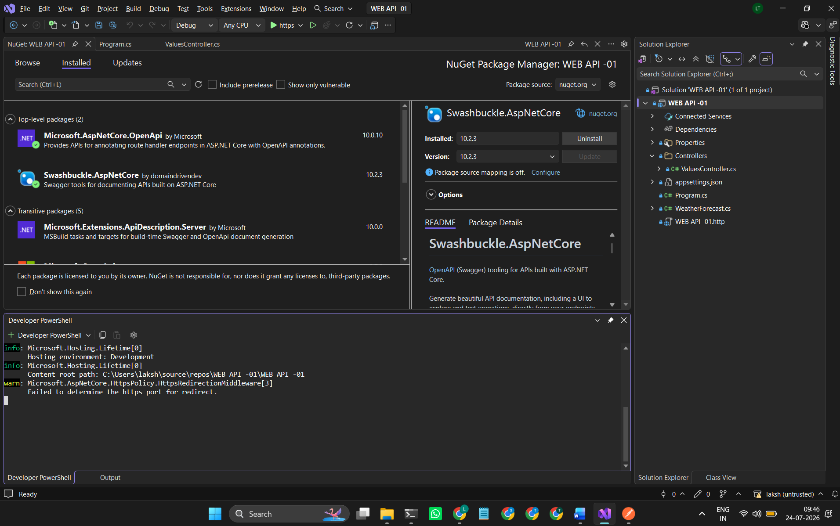
Figure 2: Swagger UI displaying the available API endpoints.
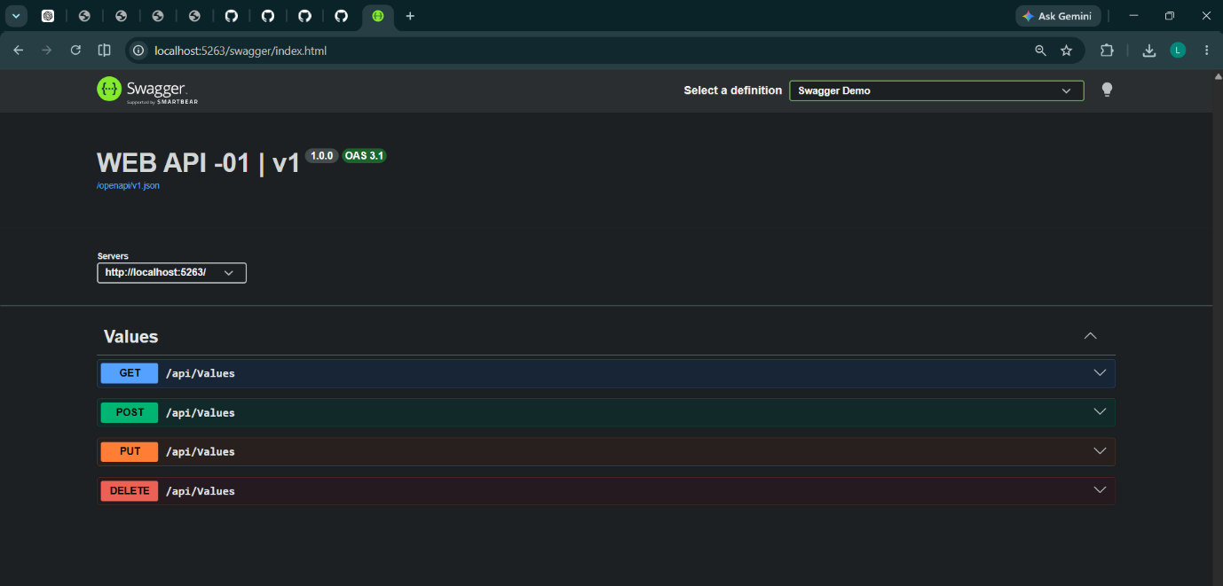

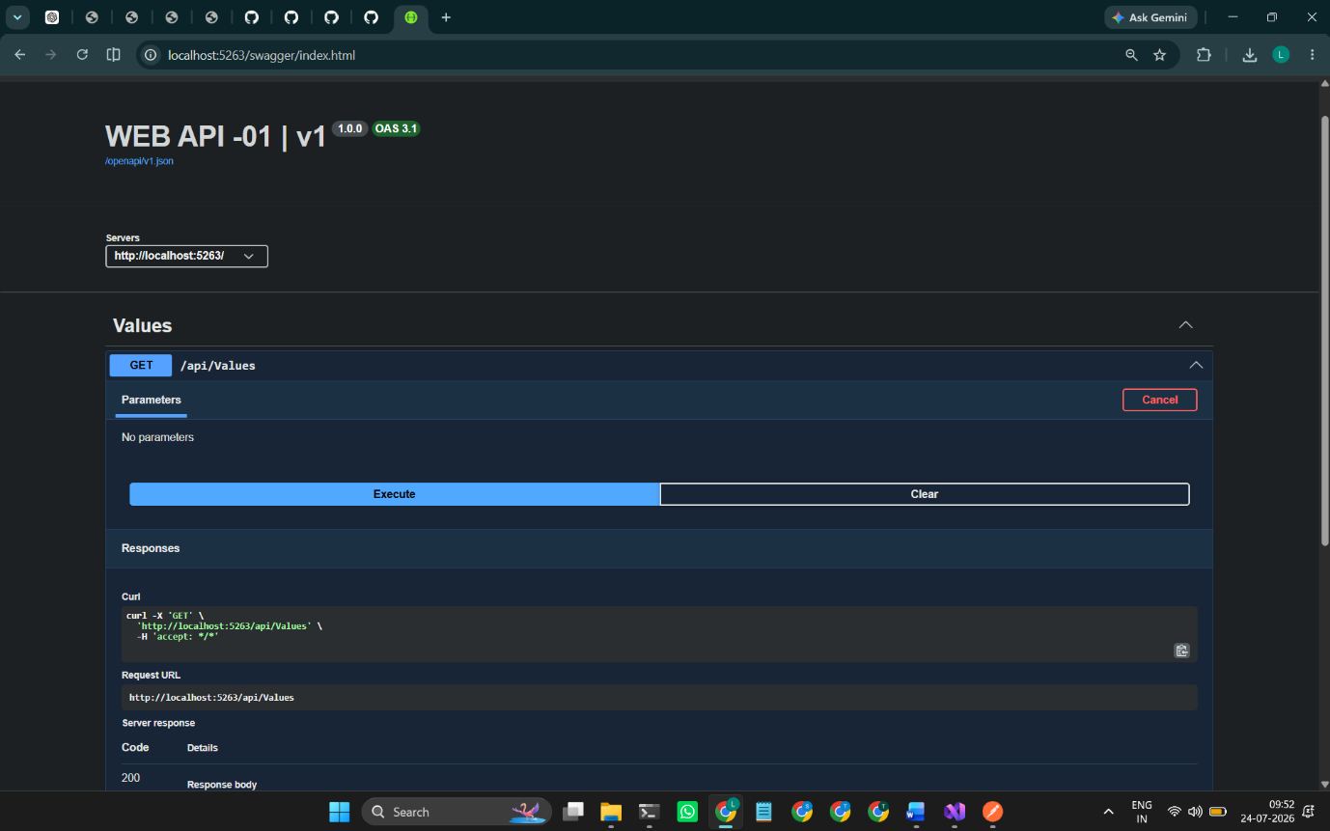
Figure 3: Successful execution of the GET method using Swagger (200 OK).
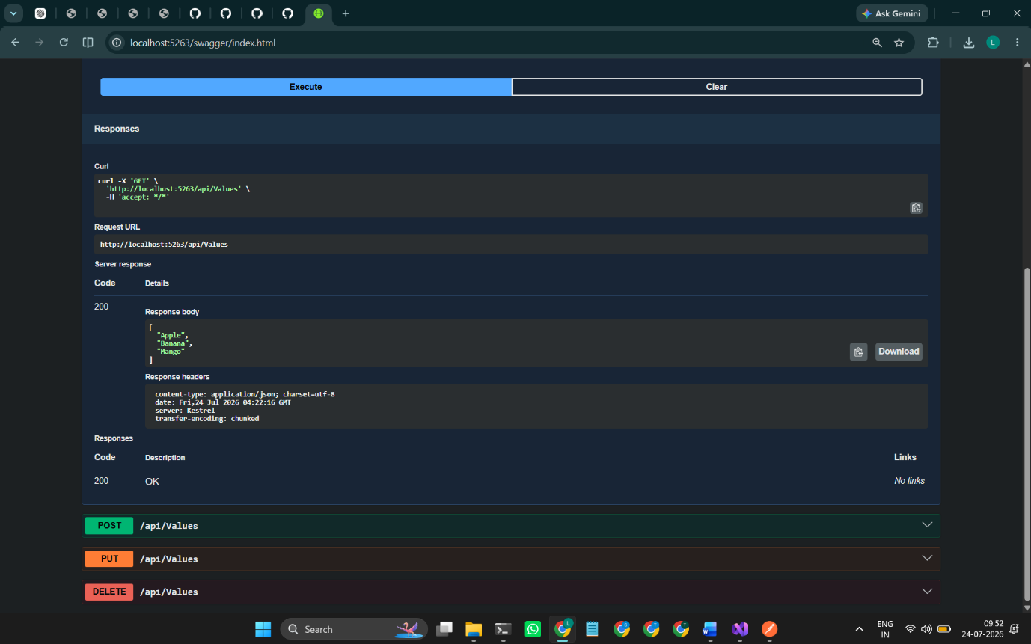

Figure 4: GET request executed in Postman showing the response body and status 200 OK.
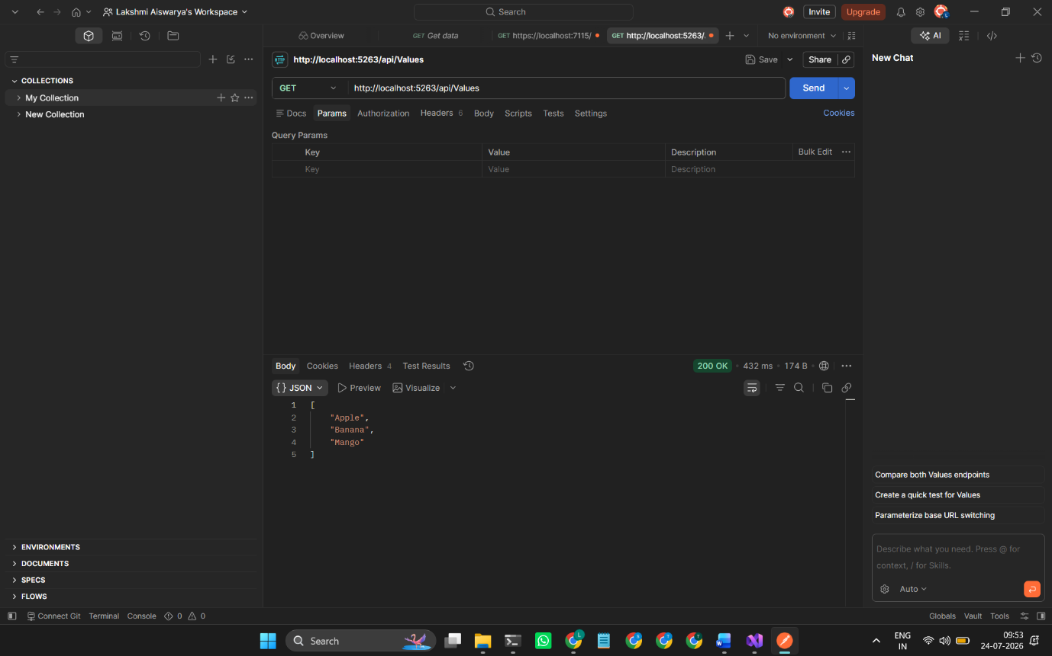

Figure 5: Postman output after modifying the route to api/Emp.

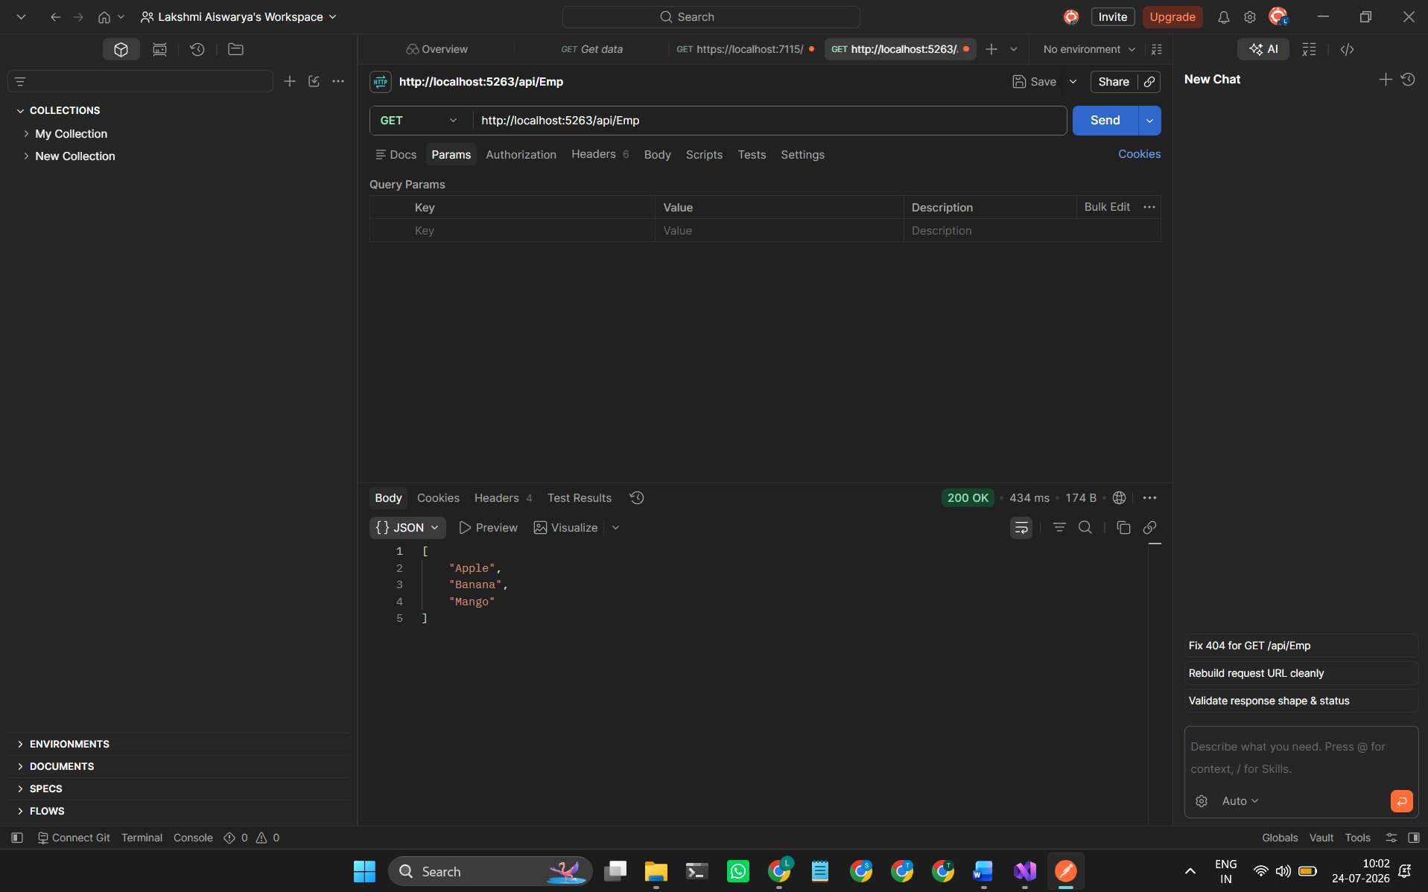

Result
Successfully created an ASP.NET Core Web API, configured Swagger for API documentation, verified the endpoints using Swagger UI, tested the GET request using Postman, and confirmed that the modified route (api/Emp) was accessible with a successful 200 OK response.

